Contents

 |  | page
1 | Introduction
2 | Context
 | School organisation
 | Pupil population
 | Performance
 | Commissioning school places
3 | The vision
 | Interdependencies
4 | Forecasting the need for places
 | School planning areas
 | Geographic priority areas
 | School building capacity (NetCap)
 | School Capacity and Provision survey (SCAP)
5 | Developing sufficiency solutions
 | Expand popular and successful schools
 | All-through schools
 | New schools
 | Temporary places or 'bulge years'
 | Closing a school
 | Out of scope of this strategy
 | Post 16 years
 | Early years
6 | Improvement priorities
 | Delivering better services
 | Caring for the vulnerable
 | Protecting our environment
 | Supporting economic growth
7 | Areas of growth and reduction in need
 | Primary planning areas
 | Secondary planning areas
8 | Short term delivery
9 | Medium term delivery
10 | Longer term: local plans
 | Annex A: The annual planning cycle
 | Annex B: Public consultation
 | Annex C: Capital funding for additional places

- Introduction
Here at Lancashire County Council we are helping to make Lancashire the best place to live, work, visit and prosper. This strategy supports the corporate priorities for 2021-2025:
- Delivering better services
- Caring for the vulnerable
- Protecting our environment
- Supporting economic growth

As the education authority for Lancashire, the county council has a range of statutory duties to fulfil. Our ambition to provide good access, quality and outcomes in education is set out in the Lancashire Education Strategy 2022-2025.

The School Planning Strategy 2022-25 delivers on this ambition with the aim to provide 'the right number of school places, in the right areas, at the right time to meet need' and is underpinned by the following principles:

- Provide sufficient school places for every child in Lancashire who wants one
- Promote high educational standards
- Provide fair access and equal opportunity
- Promote the fulfilment of every child's potential
- Promote diversity in provision
- Expand popular and successful schools, and
- Increase opportunity for parents and carers to access schools of their choice
Principles underpinning capital investment (Cabinet, 2020)

- Context
Lancashire County Council has strategic responsibility for commissioning education provision in the county. It is our statutory duty to provide a Lancashire place for every Lancashire child who wants one. The focus of this strategy is the provision of mainstream school places for children and young people aged between 4 and 16 and aligns closely with the Inclusion Strategy for children with special education needs and Alternate Provision Strategy.
School organisation
There are 628 schools in Lancashire of which 482 are primaries and 82 are secondaries which provide mainstream school places across the county. This strategy is primarily concerned with ensuring that there are enough places available at primary and secondary schools, identifying where more are needed, and where in some cases a planned reduction is necessary.
Lancashire has a 'mixed-economy' of schools (academy, voluntary aided, voluntary controlled, foundation, grammar etc.) where many determine their own admission arrangements. This relies on effective collaboration with and between maintained schools and academies in the county to ensure sufficiency of places.
An increasing number of schools are becoming academies which operate independently from the county council. New academies must be part of an academy trust, which are operated by not-for-profit companies and are funded directly by the Department for Education. We will cooperate with the conversion of any school which is becoming an academy, whether this is a conversion directed by the Secretary of State for Education, or where the governing body of a school chooses to do so.

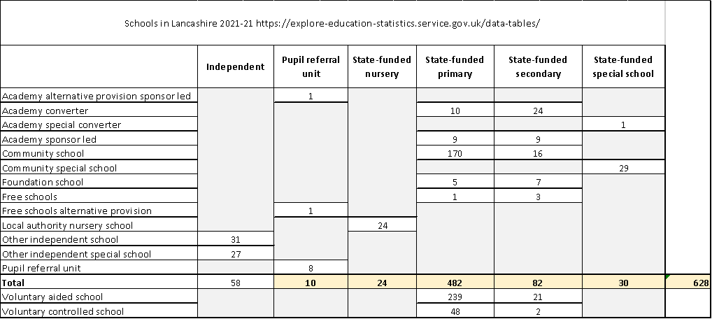

Pupil population
As at October 2021, there are 175,701 pupils attending Lancashire schools of which 101,399 attend primary schools and 67,694 attend a secondary school. At a population level, we know that:
- birth rates have fallen 6.5% over the last 5 years, and 9% over the last 10 years
- higher number of pupils are moving into secondary phase, which is creating pressure on places but where there are fewer schools, a greater proportion of which are academies not controlled by the county council
- there are pockets of growth in primary areas, mainly led by housing development and in some areas by inward migration
- emerging challenge of surplus places as primary numbers in some areas reduce
This is illustrated in the following images:

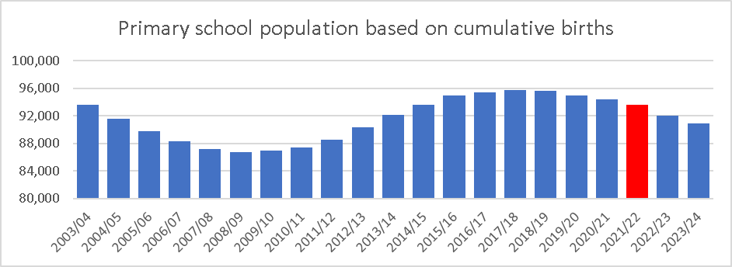
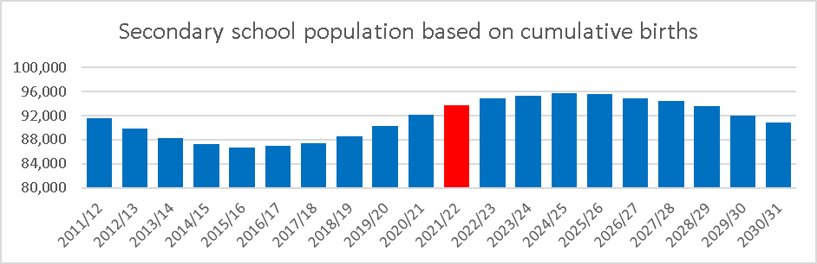

Performance
Our performance in providing school places is measured against Department for Education indicators set out in the School Capacity Survey (SCAP) scorecard each year: In the admissions round for September 2021 places, we had:
- 13,940 applications
- 86.5% gained a place in a Lancashire school at their 1st preference school (compared with 82.2% nationally in 2020)
- 96.7% gained a place in a Lancashire school at one of their three preferences (compared with 95.6% nationally in 2020)

Commissioning school places
As education authority, the county council is the commissioner of school places, and so we will be the 'proposer' for the majority of projects that address need in an area. As the diversity of school provision continues, we will collaborate with the Regional School Commissioner (RSC) for Lancashire and West Yorkshire where this entails the development of a free school or academy, and with other responsible bodies such as academy trusts, and dioceses to deliver sufficient places.
Whilst, we perform well overall, we know that in some areas we need to develop a more innovative approach to make sure there are enough places available in a shorter time to respond effectively to growth in pupil numbers. This is reflected later in the strategy as improvement priorities for change in our approach and will require closer collaboration with our school partners and, at times, a more direct approach with other responsible bodies and governing bodies to meet the need for places.

- The vision
This strategy delivers on the aims of the Education Strategy 2022-25 by seeking to provide access to sufficient places in schools delivering a good quality education and which support each child to achieve the best outcomes.
To enable these aims to be achieved, this strategy provides the 'pillar' of our approach to school place planning, namely to:
- Commission sufficient high-quality accessible places to maximise the number of place preferences secured.
- Offer diversity in the types of school available.
- Manage school capacity data and provide the statutory School Capacity Survey (SCAP) return to the Department for Education (DfE).
- Provide pupil forecasting to inform decisions on the school estate which align with other education strategies.
- Liaise with Local Planning Authorities to secure education infrastructure to support sustainable development.
- Collaborate with other services and the mixed economy of schools across the county.
Interdependencies
Through engagement with the Team Around the School & Settings (TASS) model we will develop and maintain effective, collaborative relationships that will ensure sufficient places are brought forward at the right time.
In implementing the new Admission Code, the council has put in place a new system of pupil access that aims to quicken the pace at which children and young people are able to gain a school place through 'in year' admissions. Where necessary, we will direct schools to take pupils and use the levers available through the Regional Schools Commissioner (RSC) and Education and Skills Funding Agency (ESFA) to persuade schools to make places available at the earliest opportunity.
To ensure that proposed projects that seek to address school place sufficiency take account of the nature of local educational requirements, characteristics and organisation across the school phases, proposals for building works to education infrastructure will follow the "Principles underpinning capital investment" (Cabinet, January 2020).
This approach will support delivery of the Inclusion Strategy by creating a network of Inclusion Hubs in mainstream schools around the county and by delivering expansion projects which support an inclusive approach to education.
- Forecasting the need for places
We take an evidence-based approach to forecasting the need for school places to produce 5-year pupil projections. Forecasts are updated twice a year, in December and April, using data which includes:
- current & previous years' school census numbers
- inward and outward migration (or movement) of pupils between areas and schools
- school net capacity assessment of buildings
- schools’ published admission numbers (PAN)
- birth data
- district and city council supplied planned housing data for the next 5 years
Further information on how these projections are produced can be found in our Pupil Projection Methodology.
School planning areas
To better understand need at a local level, primary schools are grouped in 70 planning areas for planning purposes, reflecting travel to school catchments. Secondary schools are grouped by district. Planning areas are reviewed annually, and revisions shared with the DfE for approval. Most recently this has resulted in changes to planning areas in Burnley and Lancaster.
We also consider places across district and planning area borders to ensure viability of existing schools, as well as number of places taken up by pupils out of county and vice versa.
Geographic Priority Areas
Within Lancashire, the area in which a child or young person has priority for a school place is known as a geographical priority area (GPA). Living within the GPA does not guarantee a place within a particular school - but offers a degree of 'priority'. GPA reviews are carried out annually to reflect changes in an area, most recently this has resulted in changes within Burnley and Chorley.
School building capacity
The need for places is determined by comparing the projected need for places against the actual capacity of schools in a planning area. It is important for this reason that schools keep us informed of any changes made to their buildings. The net capacity assessment (NetCap) is still used as the standard method for measuring the number of pupil places available in any mainstream school. The NetCap helps to determine the appropriate amount of space for teaching and learning activities.
School Capacity and Places Survey (SCAP)
Forecasts are submitted annually to the DfE as part of the School Capacity and Places Survey (SCAP) setting out our place provision and forecast of need. The SCAP then determines the level of capital grant the Council will receive, the majority of which is via the Basic Need Grant and Condition allocations with occasional other capital funding for targeted investment.

- Developing sufficiency solutions
Where the forecast has identified a clear need for additional places, we will engage with schools, diocese and trusts to understand how that need might be met and seek expressions of interest for expansion. The proposal for commissioned school places will be selected using the following criteria:
- Educational standards as determined by the latest judgement by Ofsted as Outstanding or Good. Where there is a shortage of schools meeting these criteria in an area of increased demand for places, a 'direction of travel' report will be assessed by the Education Improvement service advise where any schools with a category of 'Requires Improvement' show a clear improving trend in standards and may be suitable candidates for expansion, subject to current DfE guidance. Positive, or a clear improving trend in, pupil attainment and progress scores at Key Stages 2 and 4
- High levels of parental first preferences in particular, oversubscribed schools. Meeting parental preference comes at a significant cost therefore, where pupils are able to access a reasonable alternative, it may not always be seen necessary to provide additional places in a more popular school. We also consider whether additional places would provide places for Lancashire children or whether the quality of Lancashire schools may be drawing pupils in from other areas.
- The current size of the school
- Location of the school relative to population
- Practicalities of expansion on the existing or nearby site
- Costs of expansion
- The wishes of the governing body and school leadership. We will always seek to arrive at a negotiated solution with governing bodies however, we will use our school place commissioning powers if an alternative solution is either not available or not considered to offer the same quality of educational opportunity to local children.
- Access for pupils by public transport and other sustainable modes with the aim of reducing travel by private car and commissioned transport
Where forecasts show a need to increase the number of places available, there are a number of different approaches set out below that we can take to make sure there are enough places.

Expand popular and successful schools
We know that families and carers want to be able to access a place at popular and successful schools. As far as possible we will seek to provide additional places, when needed, at existing schools that are already achieving high standards of education or have robust school improvement plans in place. Particular attention will be paid to the effects of proposals on groups that tend to under-perform including children from certain ethnic groups, children from deprived backgrounds and children in care, with the aim of narrowing attainment gaps.
We also seek to expand schools that have high levels of first preferences for admission applications, in particular those that are regularly oversubscribed. This approach provides parents and carers with increased opportunities for obtaining a preferred school place for their child. It also helps to maintain stability within the existing family of Lancashire schools.
All-through schools
There may be circumstances where the provision of additional school places may be facilitated by altering the age range of an existing school, for example, providing additional primary school places by extending the age range of a secondary school to offer places for pupils aged 4 to11years thereby becoming an 'all through' school. To inform the decision on whether to propose an all-through school or to commission a new free school, options would be assessed against the Principles Underpinning Schools Capital Investment (Cabinet, 2020).
New schools
If expansion of an existing school or extending the age range is not possible or not appropriate, and a high number of additional school places are still required, we will propose to commission a new school. When a local authority decides that a new school is needed, it must seek proposals for the establishment of a free school, known as the 'free school presumption'. All such proposals require the Secretary of State to consider our assessments and preferences before making a final decision to approve. If the free school presumption route does not result in a suitable free school sponsor, a statutory competition can be held with the consent of the Secretary of State.
In commissioning a new school, we are mindful of the DfE's guidance on viability which suggests that primary and secondary school viability is greater at 2 forms of entry (FE) and 4 FE respectively (where 1 FE equates to 30 school places). However, in circumstances where the need for places in an area or available site size does not support this, it may be necessary to commission a smaller school.
Where we have already taken steps to address growth through the delivery of additional school places at existing schools, but a housing development will require additional mitigation, particularly to accommodate the pupils yielded by the development, a new school would be proposed.
Temporary places or "bulge years"
In some instances, rather than sustained evidence of demand for additional places, there may be a single intake year where numbers are forecast to be unusually high, followed by a fall in numbers or a return to 'normal' numbers. In these instances, we would normally use a bulge year to meet the need temporarily for one year at a single school. A bulge year can be implemented later in the process by an agreement to exceed the published admission number (PAN), therefore can be an informal change to the published or determined admission number rather than formally consulted rise. In addition to being a tool for dealing in advance with single year peaks in demand, it also allows the flexibility to react to a sudden change in circumstances and put additional places in at short notice.
Closing a school
In certain circumstances the county council can propose the closure of any category of maintained school. The governing body of a voluntary aided, foundation or foundation special school may also publish proposals to close its own school. Reasons for closing a maintained mainstream school would normally be too many surplus places, amalgamation, standards, failure (and no viable sponsor to convert to academy status), to acquire or lose religious character or replacement by another school.
The Secretary of State for Education, through the Regional School's Commissioner, can make an academy order in respect of a maintained school either on the application of a school’s governing body or if the school is eligible for intervention. Where a maintained school is judged inadequate by Ofsted the RSC is under a duty to make an academy order. The RSC may consider the viability of the school, how the school is managed or where the safety of pupils or staff at the school is threatened. RSCs will only issue academy orders to maintained schools that become eligible for intervention after failing to comply with a warning noticed issued on the grounds of low standards of pupil performance in the most exceptional of circumstances.
The Secretary of State can direct a local authority to close a maintained school that is eligible for intervention. This will usually be done where there is no prospect of the maintained school making sufficient improvement through other means of support. Before this power can be exercised the Secretary of State must consult various parties, but any such direction means that the statutory process does not need to be followed.

Out of scope of this strategy
Post-16 Education
All young people over compulsory school age are now required to continue in education or training until at least their 18th birthday. As a result, the local authority has broad duties to encourage, enable and assist young people to participate in education or training and must promote the effective participation of 16 and 17 year-olds in their area. We have further duties to secure sufficient and suitable education and training provision to meet the reasonable needs of all young people in their area by influencing and shaping provision through local partnerships and by identifying gaps, enabling new provision and developing the market. If it is determined that the market needs to be developed in the county, the local authority will work alongside the Regional Schools Commissioner and the Education and Skills Funding Agency to progress this.
Young people have a range of options in terms of continuing their education or training at a wide range of post 16 providers, such as at college; school sixth form; or following an Apprenticeship. Therefore, the local authority does not have a duty to ensure that a specific number of places are available at specific institutions but rather to have a strategic overview of the provision available in their area, hence the provision of post 16 school places is not within the remit of this strategy.
Early Years
Within many mainstream schools, there is associated early years provision, however the type of provision varies from independent providers co-located within the school or in adjacent buildings, to the school themselves offering early years provision through a lowered age range, governor led provision or private provider. The arrangement of early year's provision within an individual school is usually outside of our responsibility and as such, the provision of early year's education is not currently within the remit of this strategy.

- Improvement priorities
Taking learning from the previous strategy covering 2017 to 2020, this strategy identifies a number of improvement priorities that will drive change in how we approach school place planning and the way in which we develop projects to deliver sufficient places in future:
Delivering better services
- Lancashire has a mixed economy of schools many of which set their own admissions criteria relevant to the characteristics of the school. There is different provision in each area however Lancashire has fewer schools which are academies and a greater proportion which are maintained by the local authority and this will continue to change as increasing numbers convert. To help families and carers make informed decisions about which schools they apply for a place at, we will improve the accessibility of information available to families, carers and other stakeholders by providing details about school organisation, sufficiency and potential future need, and our plans for delivering school place projects, on an easily searchable web-based platform which is currently in development.
- Where we experience a growth in pupil numbers within a local area that outpaces our forecast numbers, we will apply warranted variation in how we deliver sufficiency solutions. For example, in areas of growth driven by rapid movement into the area, we will expand place numbers across all year groups rather than the traditional approach to expansion at reception or year seven.
- We will work in partnership with schools, the Regional Schools Commissioner (RSC) and the Education and Skills Funding Agency (ESFA) and with other responsible bodies to ensure that the appropriate levers and revenue support are in place however where necessary, schools will be directed to take pupils on roll to minimise the time spent out of education and collaborate in delivering sufficiency projects.
- Due to factors such as constraints in the existing school estate, funding limitations and a reluctance in some schools to participate in expansion projects, this has, in some areas, led to a pattern of admitting pupils above the published admission number (PAN) of a school. Where this has become relied upon as a means of securing places in the absence of other solutions, it has resulted in a reduction in the 'buffer' or planned surplus of places necessary to accommodate movement of pupils between schools. We need to understand the impact of this on the physical capacity of school buildings and plan for a managed increase in physical capacity where possible.
- We are now seeing a fall in birth rates produce significant numbers of surplus places in parts of the county which if not addressed may begin to impact on the viability of some schools. The county has a large number of small schools, mainly rural but in some urban areas, which are increasingly faced with balancing the demands of maintaining buildings, staff structures and delivering a balanced curriculum leading to financial hardship. We will engage with schools and the relevant responsible bodies to manage a planned reduction in places, and where appropriate, consolidate the school building portfolio.

Caring for the vulnerable
- Children who are new to area should be readily able to access an appropriate school place however it is becoming increasingly difficult in some areas to access a place for children where applications are made outside of the annual round of admissions. The issue of Children Missing Education (CME) is not experienced county wide but is proving a challenge in Burnley, Pendle and Preston and is influenced by several factors. This includes the EU exit which saw a rapid increase in the movement of people, followed immediately by the pandemic which has impacted on travel patterns into these areas. These districts also experience some of the highest levels of deprivation in the country where Burnley is 11th out of 317 areas, Pendle is 37th and Preston 46th. Within Burnley there are constraints in school building portfolio where several changes to school organisation in recent years have disrupted the strategy for school place provision, resulting in significant investment in school expansions to date. Many schools determine their own admission criteria which limits the influence of school improvement.
When children are missing education, there is a record kept of the referral route and the length of time the child has been out of school. It is striking that there are significant numbers of pupils, who are new to country, who are relocating to Burnley, Pendle, and Preston where the pressure for school places may already be a concern. In Burnley, for example, over 60% of the pupils on the CME list are new to country. This is mirrored in Pendle and Preston where more than a third of the pupils have not attended a school in the UK previously and there is the need for language support and liaison with the family in respect of school admission or advice around the appeal process when schools are full.
We will reduce the number of children missing education where this is the case by improving the time taken to secure a place for in-year admissions. This will be managed through a new pupil access system that comes in to effect in November 2021, to quicken the pace at which pupils are able to secure a place in a Lancashire school.
- Learning from success in other parts of the country, we will adopt a model of support for families in making a positive start to their life in Lancashire, to gain a sense of belonging and the opportunity to settle. Through the principle of warranted variation, we will implement this way of working in east Lancashire initially, to reduce the cultural shock of a relocation, and its wider impact on a whole family and effects that can hinder educational achievement and wider aspects of wellbeing. This will include the development of a physical space that becomes a single point of contact for new arrival families where they can access, or be supported to access a range of signposted services such as employment support, housing, health, school admissions, and adult learning. By enabling access to assessments that children may need they will be more readily able to access the curriculum and schools will know the next steps for each child before they start at the school. This would pave the way for transition being less challenging and with greater success so reducing school absence, and time as a pupil who is "child missing education". This new provision comes into place in November 2021.

Protecting our environment
- In response to the global challenge of climate change, the county council has committed to an ambitious carbon reduction strategy. In developing school sufficiency projects, we will identify opportunities for decarbonising buildings and delivering sustainable school accommodation within the scope of that scheme.
- In considering changes to the school estate, we will take account of the new Department for Education guidance on school land transactions (DfE, 2021).

Supporting economic growth
- Whilst our forecasts are built on nationally recognised data sets, we will seek to use other intelligence to take account of the context in which additional school places are required for example, by engaging with major employers to understand the potential implications of their workforce strategies, where employees are planning to settle and availability of places in local schools, or where district councils are experiencing a growth in social housing or building conversions for the private rental market.
- Where the growth in school places is driven by housing development, we will seek to mitigate the impact on education infrastructure through appropriate levels of developer contributions. We will collaborate with local planning authorities to ensure that this impact is understood to allow for sustainable development to be supported. This is crucial to our success in providing sufficient places in areas that are experiencing high levels of housing development. We will ensure that our developer contributions methodology is kept up to date with government guidance and expectations and takes account of our learning from planning inquiries and good practice.
DfE guidance set an expectation that developers should contribute toward education infrastructure to enable sustainable development. Lancashire County Council is not a statutory consultee in respect of its education function (unlike Highways) and so heavily relies on district planners’ co-operation and support for education infrastructure provision. Where payment is not agreed or pursued by the local planning authority the development could be considered to be unsustainable. Operating in a two-tier local government system, we need district councils to work with us in ensuring that adopted Local Plans give full consideration to the provision and funding of sufficient school places and in seeking a financial contribution and/or land from the developers.
- We will improve the pace at which projects to address sufficiency, through providing additional accommodation, are delivered. By echoing the approach used by the Department for Education, we will apply the use of standard design for school premises and access modern methods of construction such as off-site manufacture to reduce the time it takes to deliver additional accommodation. This may include the use of temporary, demountable accommodation to allow for a rapid increase in places that can be easily removed and repurposed as pupil numbers reduce at a later date.

- The school building portfolio in the county is ageing and, in some areas, may benefit from renewal. In addition, opportunities to deliver traditional models of school expansion are limited by site constraints or the operation of Private Finance Initiative (PFI) contracts to deliver building services. We will consider the implications of such constraints and identify the conditions which may mean a greater focus on the delivery of new schools.

- Areas of growth and reduction in need
Primary school planning areas
Primary school planning areas are shown in the map below with areas of growth (Red) and areas of reduction (Blue).
There is no birth led demand due to birth rates dropping and the areas of growth are housing led. Within the map and table below listing the areas, those areas that are darker require immediate consideration with the lighter areas for the future.

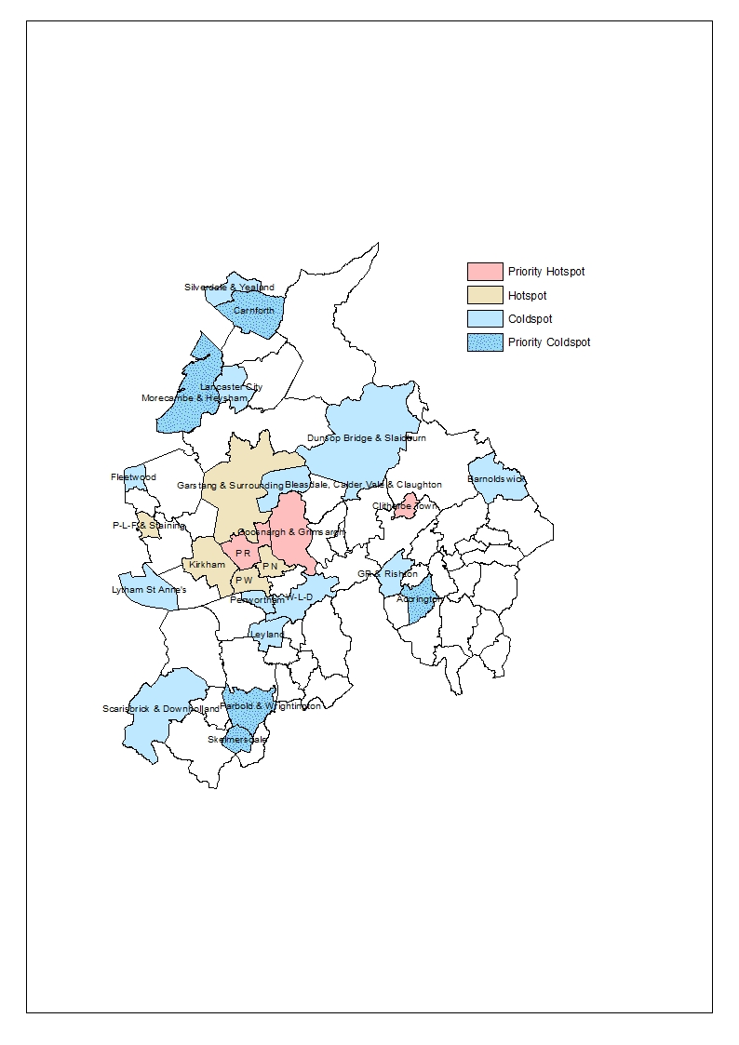

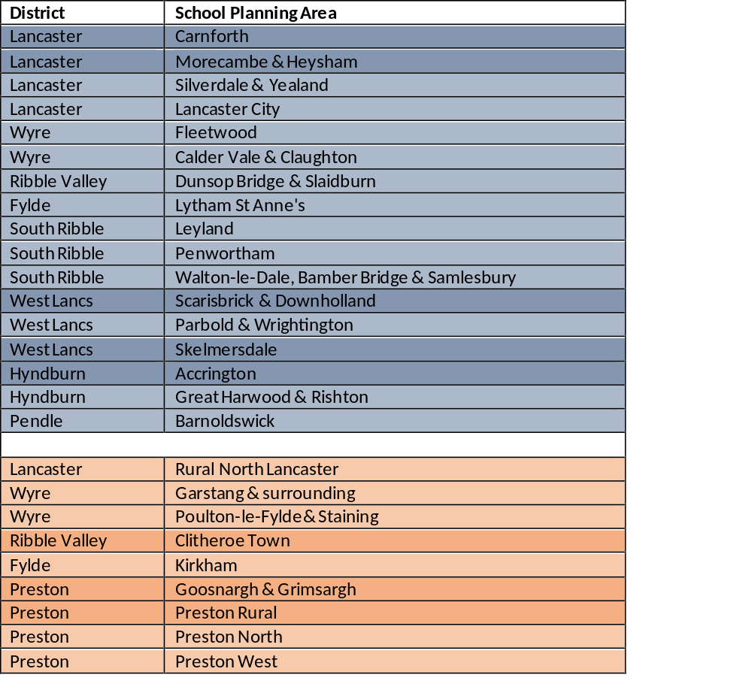

Secondary school planning areas

Within the secondary sector the areas for growth are within Burnley, Chorley, Fylde, Pendle, Preston, Ribble Valley. West Lancashire is the district with increasing surplus places.

*insert map for secondary*

- Short-term Delivery

Ribble Valley Primary

School Planning Area | Clitheroe Town
Location | Higher Standen, Clitheroe
Name | Create an all-through school by extending age range at Ribblesdale High School (Final decision December 2021)
Type | Provide additional primary school places by extending the age range of Ribblesdale High School to provide places for pupils aged 4 to11 years.
Size | 210 primary places (30 Reception places per year from September 2023)
Target Date | September 2023
Status | Site and housing contributions at Higher Standen secured in conjunction with Ribble Valley Borough Council

Ribble Valley Secondary

Location | Ribble Valley / Longridge
Name | St Cecilia's Roman Catholic Technology College
Type | School expansion
Size | 20 places
Target Date | September 2021
Status | Temp expansion from 93 to 97 in 2021 becoming permanent in 2022

Preston Secondary

Location | Preston
Name | Ashton Community Science College
Type | School expansion
Size | 60 places
Target Date | September 2021
Status | Temporary increase, for two years only, in the year 7 intake of Ashton Community Science College School in Preston, from 160 to 190 places for September 2020 and September 2021.

Burnley Secondary

Location | Burnley
Name | Unity College
Type | School expansion
Size | 300 places
Target Date | September 2021 (phase 1), September 2022 (phase 2)
Status | The admission number at Unity College has been raised from 240 to 270 in 2020 and then to 300 from 2021 through 2 phases of building works (building work ongoing)

Location | Burnley
Name | Blessed Trinity RC College
Type | Temporary one-year bulge
Size | Bulge of 30 places
Target Date | September 2021 (delivered)
Status | 2021 temporary increase of 30 pupils to Year 7, for one year only. Fixtures, Fittings and ICT.

Location | Burnley
Name | Burnley High School
Type | Temporary one-year bulge
Size | Bulge of 10 places
Target Date | September 2021
Status | 2021 increased admission number from 120 to 130 for one year only. Building work delivered.

- Medium- term delivery

Within the period of this strategy 2022 to 2025, the following areas have been identified where additional places are required either permanently or temporarily due to increased need resulting from a rise in population and/or housing development impact.

Ribble Valley Secondary

Location | Ribble Valley
Name | Additional permanent places
Type | School expansion
Size | 60 places
Target Date | September 2023
Status | Ongoing discussion with Ribble Valley Headteachers

Preston Secondary

Location | Preston
Name | Fulwood Academy
Type | School expansion
Size | 60 places
Target Date | September 2024
Status | 2022 will provide a temporary increase of 20 additional Year 7 places, monitoring need for 2024

Chorley Secondary

Location | Chorley
Name | Additional permanent places
Type | School expansion
Size | 60 places
Target Date | September 2022
Status | Ongoing discussion with Chorley Headteachers

Burnley Secondary

Location | Burnley
Name | To be confirmed
Type | School expansion
Size | 70 places
Target Date | September 2022
Status | To be confirmed.

Pendle Secondary

Location | Pendle
Name | Colne Primet Academy
Type | School expansion
Size | 225 places
Target Date | September 2022
Status | 2022 will provide a temporary increase in the admission number from 165 to 210, for one year. To become permanent in 2023 (subject to academy consultation and ESFA approval). Capital project approved by Cabinet September 2021.

Pendle Secondary

Location | Pendle
Name | SS John Fisher and Thomas More Roman Catholic High School
Type | School expansion
Size | 100 places
Target Date | September 2022
Status | 2022 will provide a temporary increase in the admission number from 160 to 180 places, for one year. To become permanent in 2023. Capital project approved by Cabinet in September 2021.

Pendle Primary

Location | Pendle
Name | To be confirmed
Type | Temporary accommodation
Size | To facilitate take up of existing places
Target Date | January – March 2022
Status | 2022 will provide a temporary increase in accommodation to support in-year admissions.

- Longer term: Local Plans

District Councils, as local planning authorities, are required to produce a Local Plan that sets out the vision for local development in the area. Close collaboration with each district and city council enables us to identify where their Local Plans may require additional education infrastructure. As a result, a number of sites have been reserved with the potential to bring forward new schools. Set out below is a summary of where sites and/or financial contributions have been sought from housing developers towards potential projects anticipated to be beyond the scope of this strategy. As longer-term projects we will continue to monitor forecasts, the delivery of developments and so refine the extent which each project is required. Many of these projects are dependent on collaboration between the county council and local planning authorities to secure these sites or education contributions from developers, without which the viability of each project is at risk.

District | Phase | Summary of contribution
Lancaster | Primary | New primary school sites or expansions are being sought at North Lancaster Development, East Lancaster Development, Bailrigg Garden Village and South Carnforth Development.
Lancaster | Secondary | A new secondary school site is being sought in conjunction with the Bailrigg Garden Village development, subject to future demand for places and the pace of development of this site.
Wyre | Primary | New primary school sites are being sought in the Garstang area, Thornton Cleveleys, Great Eccleston and Poulton-Le-Fylde to address demand from new housing.
Wyre | Secondary | Education contributions are being sought for existing secondary school expansions in conjunction with multiple developments in Wyre.
Fylde | Primary | A new primary school site has been secured at the Whyndyke Farm development. A new primary school site has been secured at Queensway.
Preston | Primary | Two sites requested for primary schools as part of North West Preston Masterplan. School site secured as part of the Cottam Hall housing development. A new primary school site has been secured on the former Whittingham Hospital site.
Preston | Secondary | A new secondary school site is being sought in conjunction with North West Preston Masterplan.
South Ribble | Primary | School site secured as part of the Leyland Test Track housing development. A new primary school site is being sought in the Penwortham area.
Rossendale | Primary | Seeking to secure education contributions for a potential new school site or expansion to existing schools in conjunction with the strategic development at Edenfield.
Annex A: The annual planning cycle

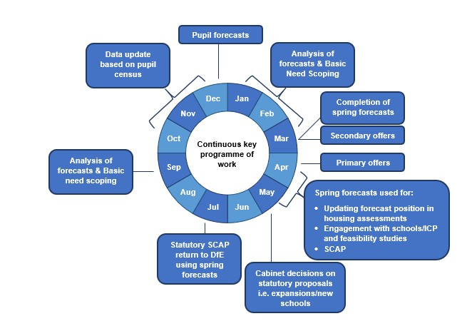
Data gathering, analysis and scoping out focused areas of need for additional places and other education priorities
Conduct desk top studies of school sites and capital programme budget position
Where need is confirmed, begin engagement with TASS, local schools, diocese and responsible bodies/Trusts and elected members
Invite Expressions of Interests to meet the sufficiency gap
Conduct Feasibility Study and assess potential projects against the Principles Underpinning Capital Investment (Cabinet, 2020) To ensure the sufficiency and sustainability of school places:
- Education provision is inclusive, reflects the needs of the community, skills requirements and economic development
- Infrastructure development should not destabilise education improvement in the area
- Consideration is given to both mainstream and special needs capacity
- Support local demand and minimise need for capital expenditure where possible
- Maximise capacity in Private Finance Initiative and Building Schools for the future premises
- Enable parents and carers to access places at the right time
- Prioritisation of condition related works utilising Department for Education guidance on good estate management for schools
- Deliverability of projects taking into account factors such as cost, site conditions and timescale.
Decision making
- Cabinet member briefing
- Report to Capital Board to secure funding where building works are required
- Cabinet approval and permission to consult where appropriate

Annex B: Public consultations
As the commissioner of school places, the county council will make the final decision on the majority of school organisation proposals, with the exception of new academy schools. In doing so we will consider the views of all those affected by the proposals or who have an interest in them including: pupils; families of pupils; staff; other schools and colleges; local residents; diocesan bodies and other providers; neighbouring local authorities; and any other relevant local partnership or group that exists in the area. This includes the consideration of comments submitted during the statutory representation period.
We consider all views put forward but give the greatest weight to representations from those stakeholders likely to be most directly affected by the proposals, for example the parents and carers of children who might be eligible to attend proposed new or expanded provision.
Proposals to significantly expand, alter, or close a school must follow a statutory process. In Lancashire, to ensure that we fully understand the impact of a proposal on stakeholders, we also carry out an informal consultation before starting the statutory process. Hence the four stages of statutory consultation are five stages in Lancashire:
- Informal Consultation (non-statutory)
- Stage 1: Publication
- Stage 2: Representation
- Stage 3: Decision
- Stage 4: Implementation

Annex C: Capital funding for additional places

This section should be read this alongside the Capital Strategy for Schools which is produced annually. There are three sources of funding for additional school places available to the county council:
DfE Basic Need Grant
Capital funding for schools is received in the form of capital grant from the DfE, the majority of which is via the Basic Need Grant and Condition allocations with occasional other capital funding for targeted investment. The actual figure received is based on information provided to the DfE through the annual School Capacity (SCAP) and the Condition Spend Data Collection (CSDC) return which sets out place provision and forecast of need. Over the past five years this has been a one or two-year allocation only which can impact on the ability to forward plan.
School contributions

Schools may wish to contribute towards expansion projects to address wider suitability issues or carry out other planned works to minimise disruption and gain added value through pooled resources. In the main this has mainly been to meet the cost of fixtures & fittings, ICT etc.

Section 106 or Community Infrastructure Levy (CIL) from developers

Where new housing development creates a demand for school places in excess of those available, the DfE expects that local planning authorities will work with education authorities to secure contributions towards education infrastructure. In Lancashire we work with district and city councils to seek a financial contribution and/or land from the developers that is proportionate to impact, in order to mitigate against the effect of any new development.
If a developer does not agree to payment of the requested education contribution or the local planning authority does not pursue our request on its behalf, we cannot guarantee that pupils yielded by the development will be able to access a school place within reasonable distance from their home, so the development could be considered to be unsustainable. If the development is still approved without any education contribution or a reduced contribution, we would be seeking clarification from the local planning authority on how the shortfall of education places will be addressed. Further details on our planning obligations are available on our website: http://www.lancashire.gov.uk/council/planning/planning-obligations-for-developers.aspx
Statutory proposals to alter school provision cannot be published without the necessary capital funding being identified and secured. Therefore, with reduced capital available to the council, in areas where housing development contributions are secured from developers to mitigate the impact of their development, the authority will be able to be more responsive to emerging need and able to provide additional places more quickly than in areas where this is not the case.

